Code validator and git-hub check

Git-hub: <https://github.com/reteth/WEBL1/projects/1>

Code validation:

Index.html:

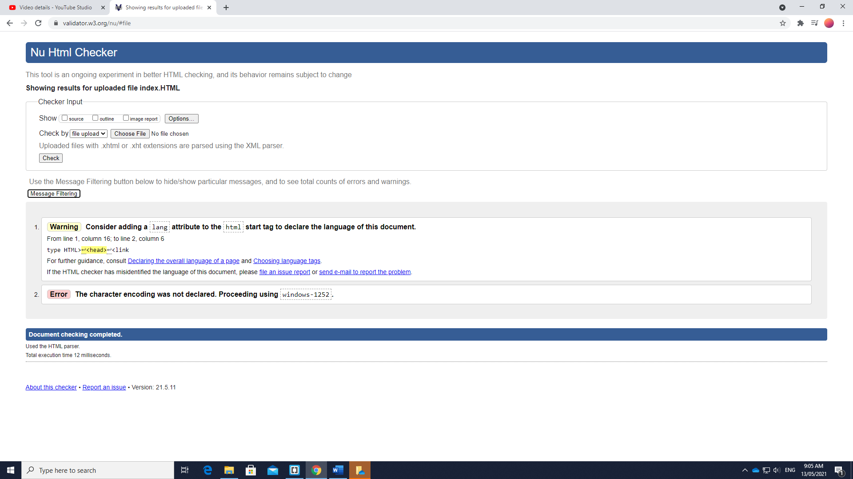

Catalouge.html: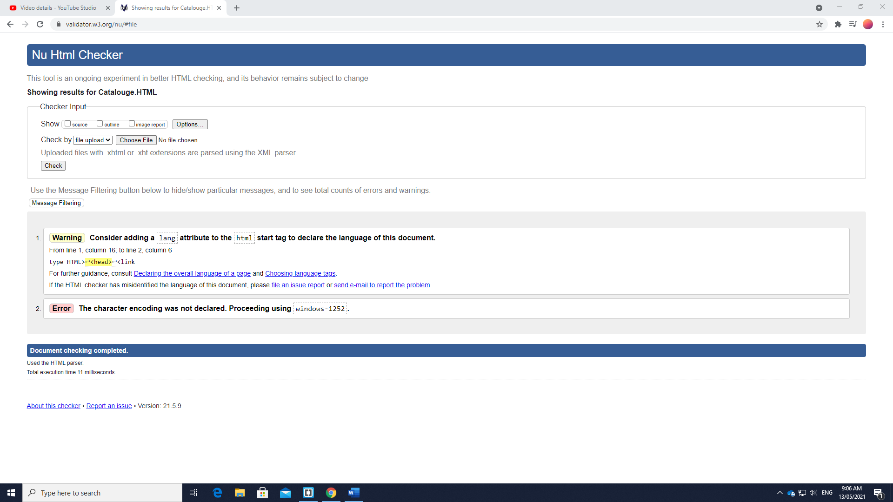

About us.html: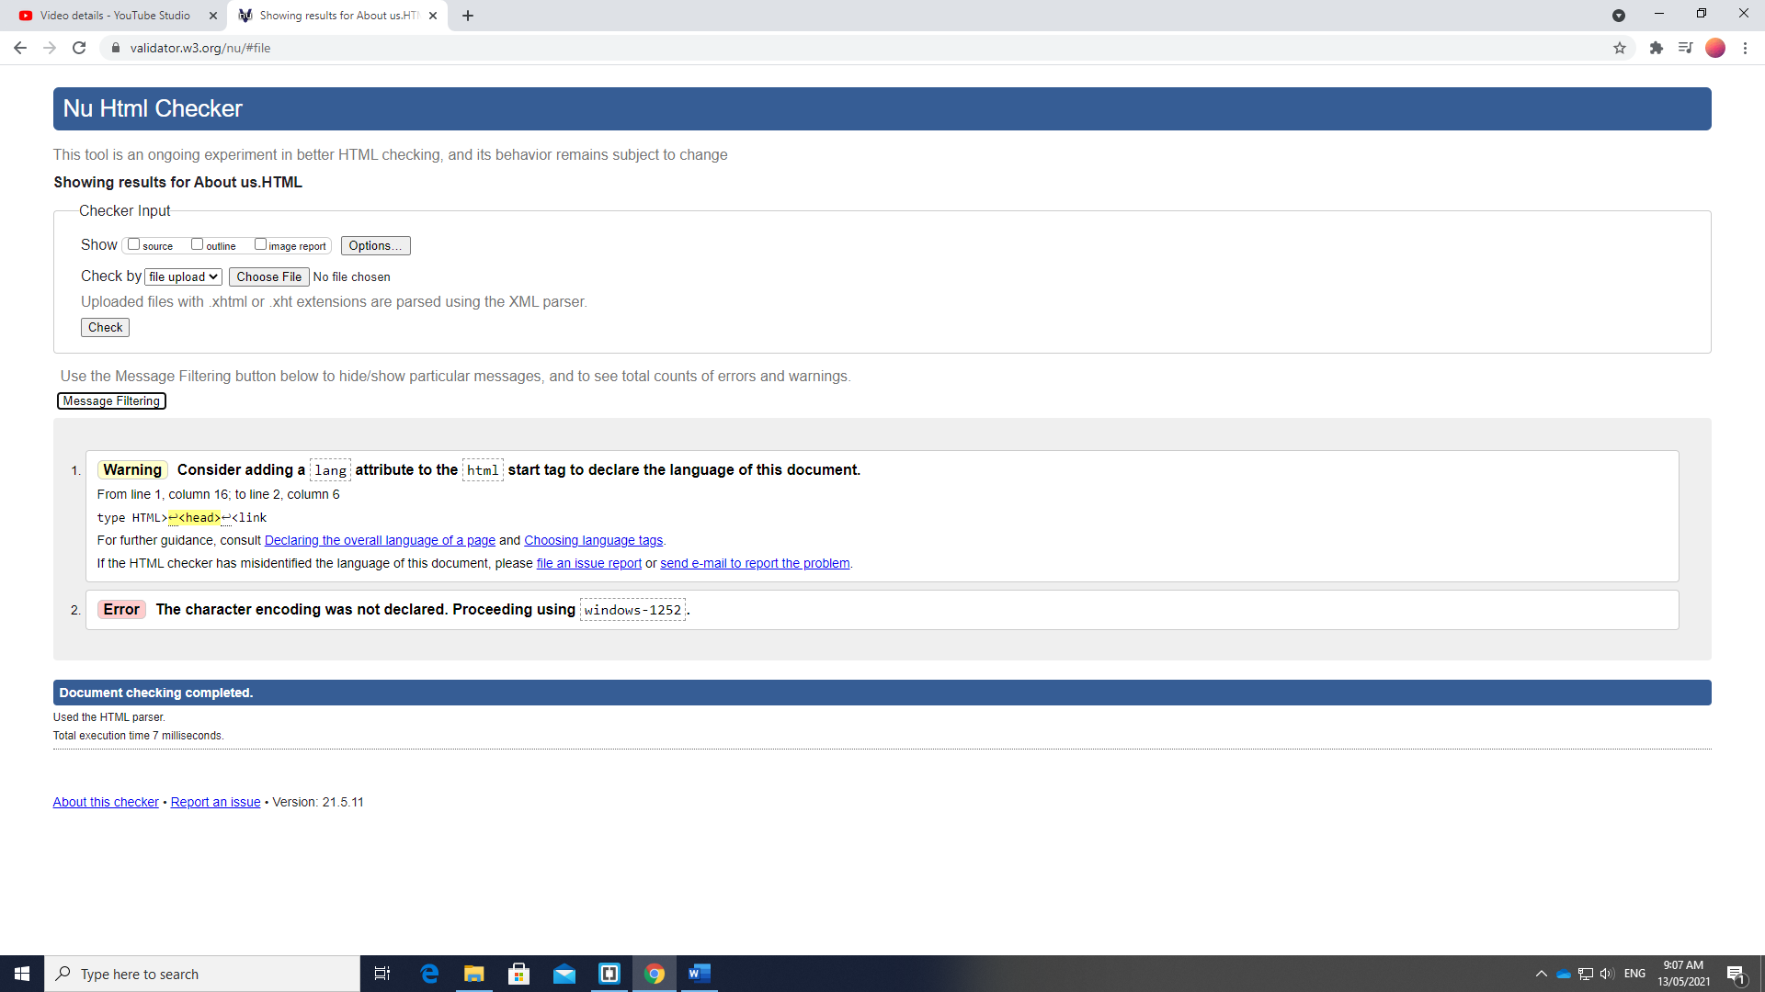

Jeanbuy.html: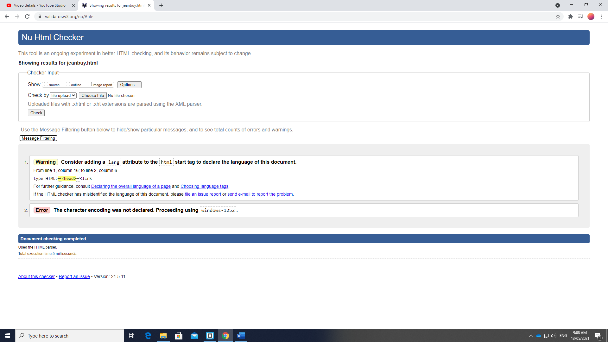

Shirtbuy.html:

